Azamat Salamatov

Pr. Marvin Johnson

MATH 1312 - 1

Homework 1

March 21, 2023,

Homework - 3

95) a)

**i.** The sample mean height of 48 male Swedes is 71 inches, so, x = 71.

**ii.** The standard deviation of height among the population of various ethnic groups is 3 inches, so,  σ = 3.

**iii.** The size of male Swedes surveyed from the various ethnic groups is 48, so, n = 48

b) In words, define the random variables, X and X

X = height of the male Swedes

X = mean height of the 48 male Swedes

c) Normal distribution, because population standard deviation is given and sample size > 30

d) **i.** Confidence interval = (70.151, 71.839)

**ii.** Graph for the confidence interval

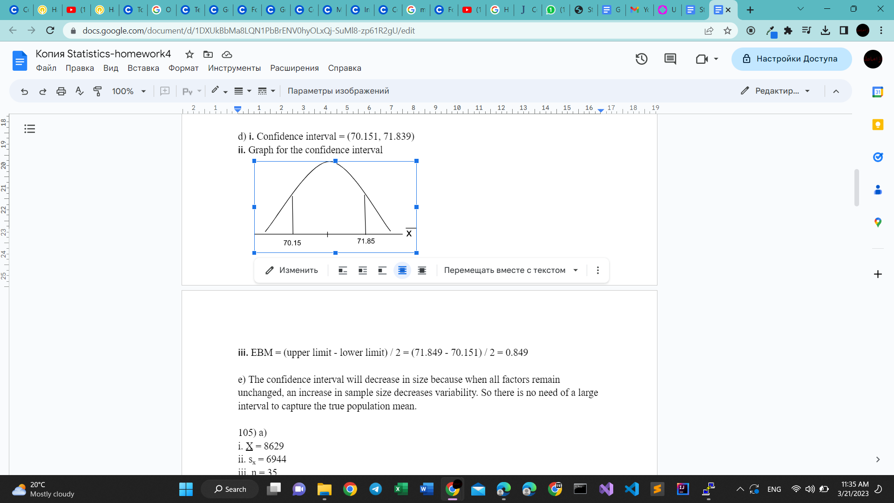

**iii.** EBM = (upper limit - lower limit) / 2 = (71.849 - 70.151) / 2 = 0.849

e) The confidence interval will decrease in size because when all factors remain unchanged, an increase in sample size decreases variability. So there is no need of a large interval to capture the true population mean.

105) a)

i. X = 8629

ii. sx = 6944

iii. n = 35

iv. n-1 = 34

b) X =  number of enrollments at community colleges

X = sample that is used to estimate the population mean.

c) The distribution needed for this problem is t distribution with parameters tn-1

=> t35-1 = t34

d) i. CI: (6244, 11,014)

ii.

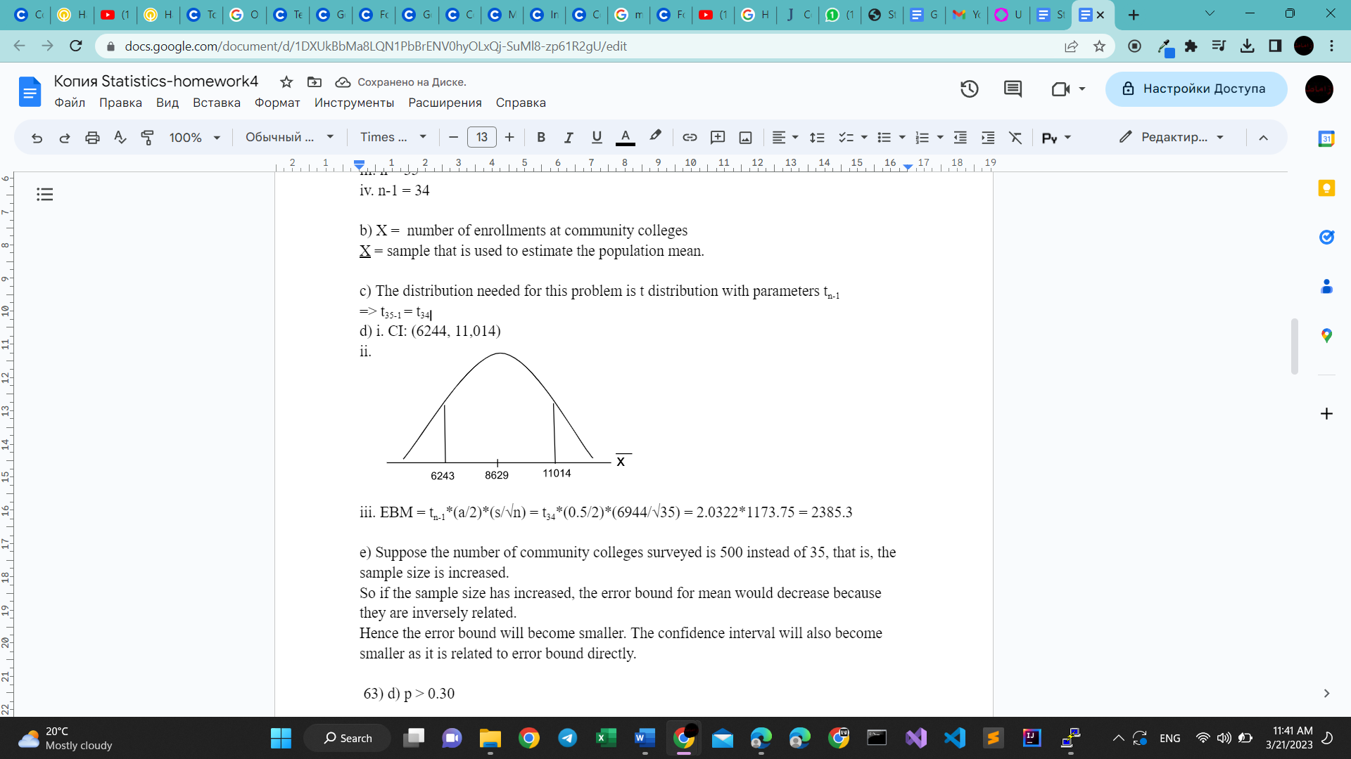

iii. EBM = tn-1*(a/2)*(s/√n) = t34*(0.5/2)*(6944/√35) = 2.0322*1173.75 = 2385.3

e) Suppose the number of community colleges surveyed is 500 instead of 35, that is, the sample size is increased.

So if the sample size has increased, the error bound for mean would decrease because they are inversely related.

Hence the error bound will become smaller. The confidence interval will also become smaller as it is related to error bound directly.

 63) d) p > 0.30

66) a) Type I error is concluding that the mean number of years Americans work before retiring is not 34, when it is actually 34.

Type II error is concluding that the mean number of years Americans work before retiring is 34, when it is actually not 34.

b) Type I error is concluding that more than 60% of Americans vote in presidential elections, when it is actually at most 60%.

Type II error is concluding that at most 60% of Americans vote in presidential elections, when it is actually more than 60%.

c) Type I error is concluding that the mean starting salary for San Jose State University graduates is less than $100,000 per year, when it is actually at least $100,000 per year. Type II error is concluding that the mean starting salary for San Jose State University graduates is at least $100,000 per year, when it is actually less than $100,000 per year.

d) Type I error is concluding that the percentage of high school seniors who get drunk each month is not 29%, when it is actually 29%. Type II error is concluding that the percentage of high school seniors who get drunk each month is 29%, when it is actually not 29%.

e) Type I error is concluding that fewer than 5% of adults ride the bus to work in Los Angeles, when it is actually 5% or more. Type II error is concluding that 5% or more of adults ride the bus to work in Los Angeles, when in fact fewer than 5% do.

f) Type I error is concluding that the mean number of cars a person owns in his or her lifetime is more than ten, when it is actually not more than ten.

Type II error is concluding that the mean number of cars a person owns in his or her lifetime is not more than ten, when it is actually more than ten.

g) Type I error is concluding that the proportion of Americans prefer to live away from cities, given the choice is not about half, when it is actually about half.

Type II error is concluding that the proportion of Americans prefer to live away from cities, given the choice is half, when it is actually not half.

h) Type I error is concluding that the Europeans mean paid vacation each year is not six weeks, when it is actually six weeks.

Type II error is concluding that the Europeans mean paid vacation each year is six weeks, when it is actually not six weeks.

i) Type I error is concluding that the chance of developing breast cancer for women is less than 11%, when it is actually at least 11%.

Type II error is concluding that the chance of developing breast cancer for women is at least 11%, when it is actually less than 11%.

j) Type I error is concluding that the private universities mean tuition cost is more than $20,000 per year, when it is actually at most $20,000 per year.

Type II error is concluding that the private universities mean tuition cost is at most $20,000 per year, when it is actually more than $20,000 per year.

79) Simple mean = 83, standard deviation = 10

H1: M <= 83

H2: M > 83

X = the mean work week for women

tn-1 = t81-1 = t80

t = (X - M)/(s/√n) = (83 - 80)/(10/√81) = 3 / 1.111 = 2.7

TDIST(2.7, 80, 1) = 0.00423

p-value = 0.004



X = 83, M = 80, p-value = 0.004

i. Alpha: Here alpha value is given as 0.05

ii. Decision: Reject hypothesis H1

iii. Reason for decision: Because p-value < a, therefore, reject the H1 hypothesis.

iv. Conclusion: The p-value is less than the considered level of significance 5%. Therefore, the H1 hypothesis gets rejected while the H2 hypothesis is accepted. Hence, there is sufficient evidence to insure that the mean work week for women is more than 83.

The 95% confidence interval can be calculated as shown below:

X ±  t80 * s *(√n) = 83 ± 2.178*(10/√81) = 83 ± 2.42 = (80.58, 85.42)

Here is the sketch of confidence interval:

